*CS 353 Software Engineering*

Second Deliverable



A carpooling app for Habib University Students

**Group Members:**

Abeera Tariq (at02787)

Nisha Shaikh (ns02530)

Muhammad Ahsan Syed (ms02743)

Ubaid Ali Farooqi (uf02900)

*Invite Link for trello board:* <https://trello.com/invite/b/qVjGp6rH/7c36474812b54827f39838d0326c7dde/carpool-system>

*Submitted on: 31-March-2019*

**CONTENTS**

* Updated Proposal
* User stories and activity diagrams
* Class Diagram
* Entity Relationship Diagram (ERD)
* Non-functional requirements
* Mock Screens

**UPDATED PROPOSAL**

**Abstract:**

The project deals with a web-app/Phone app through which students of any institution (starting from Habib University) can effectively connect with each other for carpooling.

**Purpose and Introduction:**

Most students studying at any institute face conveyance problems one-way or the other. We can categorize them as:

1. Students who cannot afford to pay for their conveyances.
2. Students who have vehicles that they can use for travel however; they still have a hard time affording the fuel expenses.

The solution to this problem could be a system that facilitates communication between two and effectively schedule rides.

**We can explain the user functionality through a user case:**

**We divide our users into two classes:**   
1. Drivers (Those users that have a car and want others to travel with them)  
2. Riders (Those users that do not have a car and want to travel with someone who owns a car)

**Initial Process:**   
As a user who is currently looking for carpooling (driver or rider) would be able to register on our platform through the sign up form. Once they do it the first time, their details will be saved so that they will just have to login the next time.  
  
**Starting a carpool:**  
Every user has the option to be able to start a carpool (whether they are going to go in their own car or through any external conveyance).

**Specifications:**  
Once a single user generates a carpool request, its notification will be sent to all users registered on the system.   
  
That notification will have all the details of the carpool which is set by the requesting user that will include location of meetup, date, time, capacity, destination and money (if any).   
  
Any person who receives the notification should be able to get an option to send their own destinations as well and specify the number of people accompanying them.   
  
Once they reply to the notification, it goes back to the initial requester who will give the final approval. Once that is done they will be meet at their specified location and carpool together.

**The specifications we have thought so far are as follows:**

* We will have a login
* We will have a sign-up page
* The home page will have an option to post and to search rides
* For posting ride, driver will enter all required information
* For searching rides, rider can see all available posts of drivers
* If there are no current requests then it should be empty
* It will also have a log out button.
* We will include a directory of all registered users
* All registered users will also have access to the directory.
* The home page should have the entire current request listed in a queue.
* If there are no current requests then it should be empty
* There should be a button that should be able to start a new request
* If an user has requested to carpool then they should have the option to delete the request
* The request should get deleted automatically once the time period is reaches
* Once the new request button has been clicked, a pop-up/new page will open where we will add all further detail and confirm
* Once a user receives a notification and click on accept, a pop-up/new page will open where it will ask you to give the info back to the requester.
* Once we have replied to the notification, it will still remain in the notification panel but will mention that its pending

**The software/tools that will be used are:**

* Angular/Ionic 2/3 for frontend
* Python(Django)/NodeJS/ASP.NET for backend
* Visual Studio
* MYSQL
* DB Designer
* Visual Code
* Adobe Photoshop
* Trello

Extras:

* Ionic DevAPP for app testing

**Some specifications are not in our scope:**

* We are not involving any form of exchange of credit or cash
* We are not helping in booking actual rides
* We are not giving a layout through maps of different destinations

**Specifications we will work on for this course:**

* Login
* Sign up
* Post request for ride (From driver)
* Search rides available (For riders)

**Process model chosen and reason:**

The process model that we choose to use is **SCRUM** because even with the details, the ending UI is still not clear. Unless we break the project into smaller details and solve some relevant part of it first, we will not be able to get an understanding of the entire project.

**USER STORIES AND ACTIVITY DIAGRAMS**

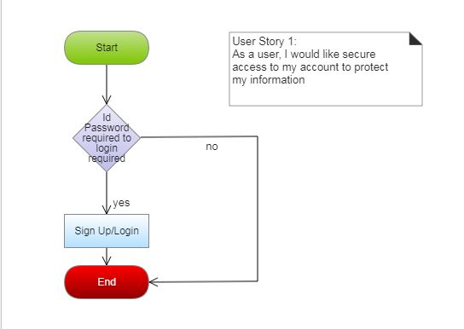

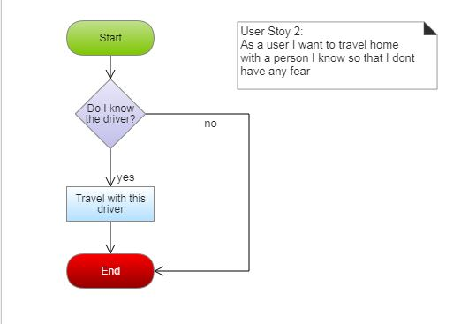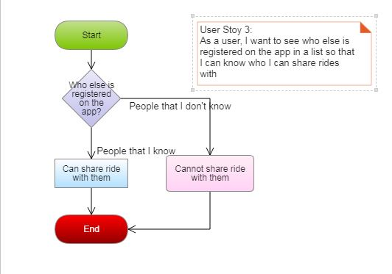

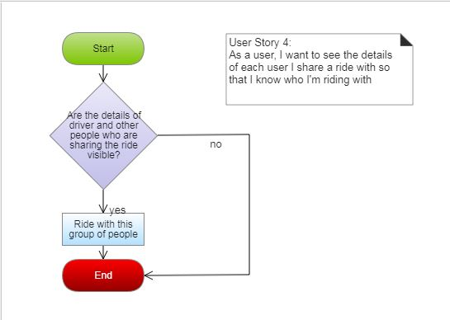

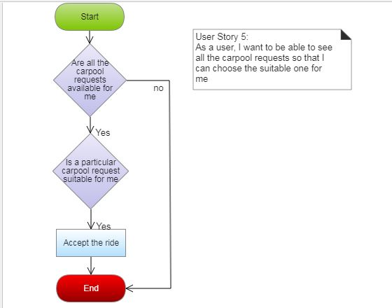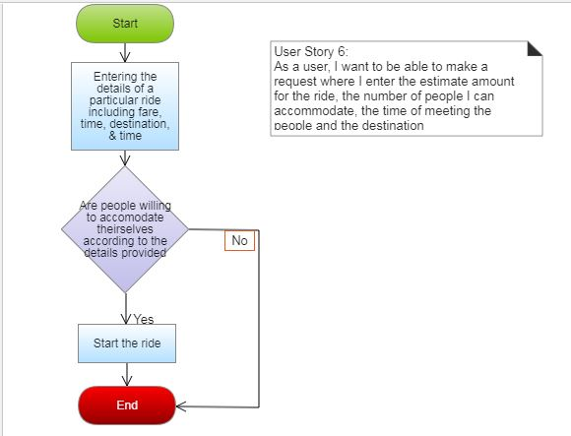

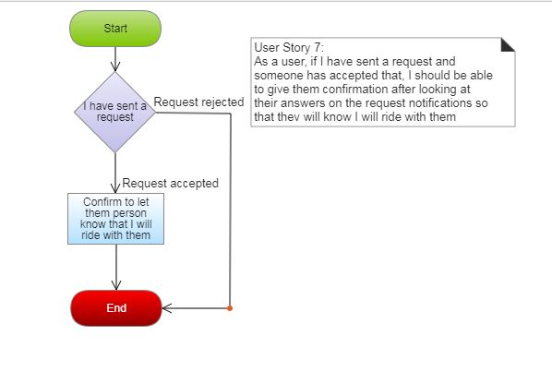

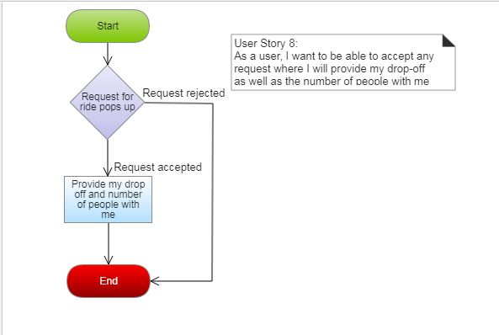

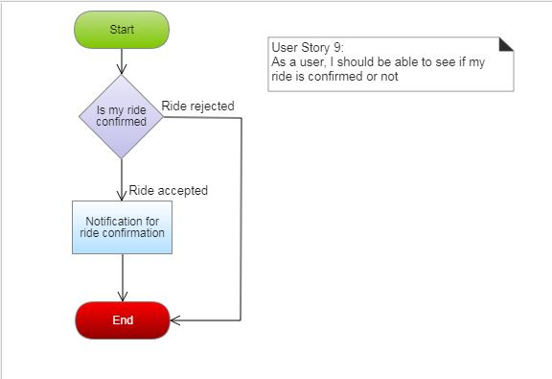

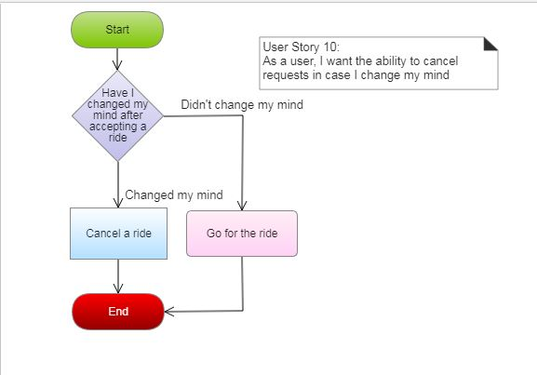

**CLASS DIAGRAM**

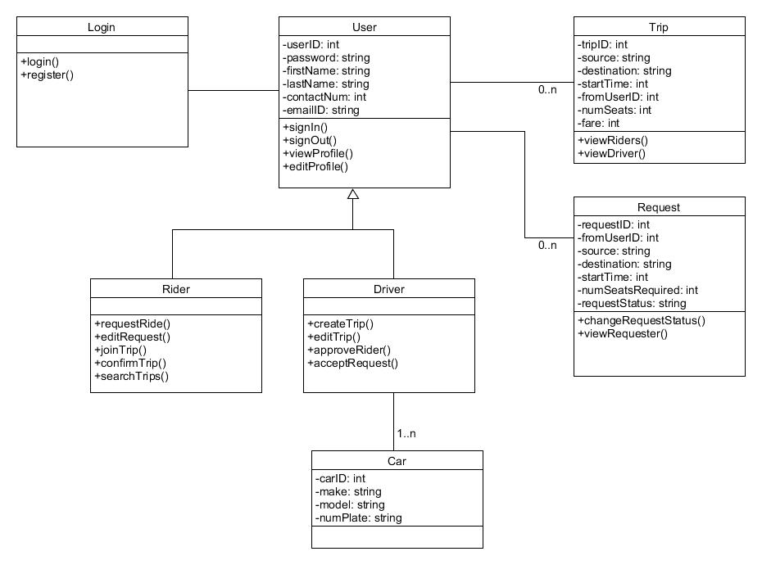

**ERD**

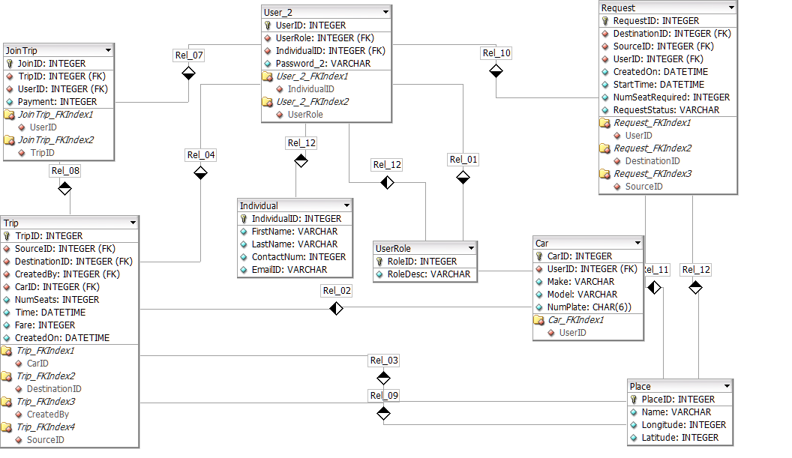

**NON-FUNCTIONAL REQUIREMENTS**

* The app should be available 24/7
* There should be a good internet connection established for the app to work and show content.
* Device should have location access enabled.
* The interface should be easy to use for all kinds of people.
* Security requirements; abstraction of user information, password protection, access control based on user role (driver/rider).
* The app should be capable of having 1000 (strength of the HU student body) users support.
* Should be able to run on all popular phone and desktop browsers.

**MOCK SCREENS**

**Login Page**

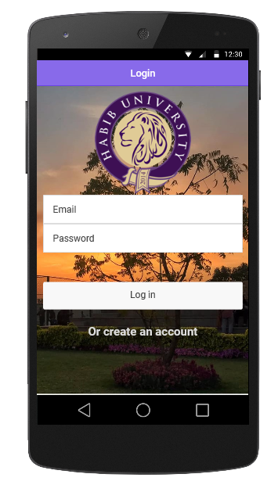

**Sign-up Page**

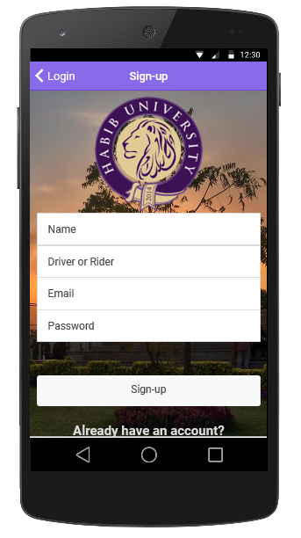

**Post Ride or Search for a Ride**

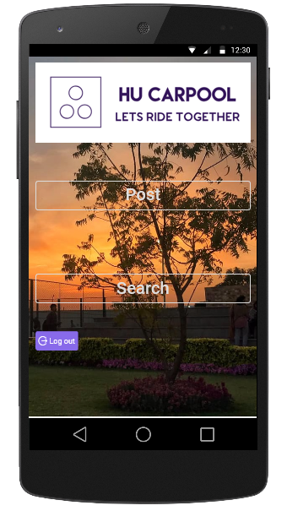

**Posting Ride (Driver access)**

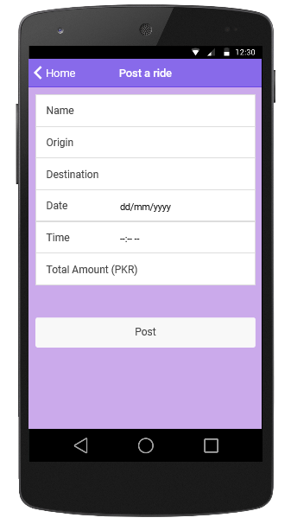

**Search for a Ride (Rider Access)**

